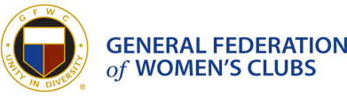

GFWC Woman’s Club of Westminster, Inc.
Press Release
Contact Mary Lou Poirier
gloupoirier@gmail.com or 410-871-9102
Jo Harp installed as President of GFWC Maryland Federation of Women's Clubs Western District.

On May 18, Jo Harp, a member of GFWC Woman’s Club of Westminster, Inc. was installed as President of the GFWC Maryland Federation of Women’s Clubs Western District. She will hold office for two years. The Clubs are members of the General Federation of Women’s Clubs (GFWC), an international nonprofit organization that brings together local women’s clubs in a collective effort to strengthen communities and enhance the lives of others through volunteer service.
Harp, a long-time member of the Westminster club, currently serves as Co-Chairman of its Conservation Community Service Project, and has served in the past as its president and held other offices. She is also the Co-Chairman of Membership for GFWC Maryland.
###

Photo Caption: Jo Harp (on left) is shown with her installation officer, Debbie Spinnenwebber, past President of the GFWC Western Maryland Community Club,Inc.

